TEMPLATE AND GUIDANCE FOR PREPARING STUDY QUALITY ASSURANCE/QUALITY CONTROL (QA/QC) PLAN – Delete this page upon submission

Overview
HEI requires Principal Investigators to prepare QA/QC plans that document the planning, implementation, and assessment procedures for a study and the QA/QC activities that will be applied. Investigators may use this template to create a QA/QC plan to document the following components:

- Brief Description of Study Aims and Design and Data Flow
- List of Standard Operating Procedures (SOPs) and Data Protocols
- Quality Control Procedures for Data Collection
- Data Processing Procedures, Data Linkages, and Data Analyses
- Data and Records Management
- List of Qualified Personnel

There is no page limit, although appendices are encouraged to help maintain clear messages in the main document.

Relevant HEI Policies and Procedures

- Data Access and Transparency
- Quality Assurance
- Investigator Commitments

QA/QC Plan Approval Process
A preliminary QA/QC plan should be submitted to HEI before the study contract is signed and should include as much information as is available at the time (Figure 1). HEI staff and the Research Committee will review and provide any necessary feedback for consideration as the investigators finalize their QA/QC plans. Throughout all stages of QA/QC, the HEI scientist overseeing your study will consult with the HEI QA/QC Manager as needed.

A final QA/QC plan should be submitted within 2 months of the study start date specified in the fully executed contract between the investigator and HEI. The final QA/QC plan should be comprehensive and in sufficient detail for an independent researcher to replicate and verify the study. The final QA/QC plan will be reviewed and approved by the HEI QA/QC manager and research committee. Data collection and analysis can start only after the final QA/QC plan has been approved by HEI. If an approved QA/QC plan is not on file at HEI, the study cannot continue, and the contract will be placed on hold.

During implementation of the study or review of the Investigator’s Final Report, the HEI Research or Review Committee and the HEI-selected audit team, if applicable, might require submissions of updated QA/QC plans and request modifications. However, the investigators and their institutions have the primary responsibility to prepare and adhere to the QA/QC plan and to keep the plan current as the study progresses.
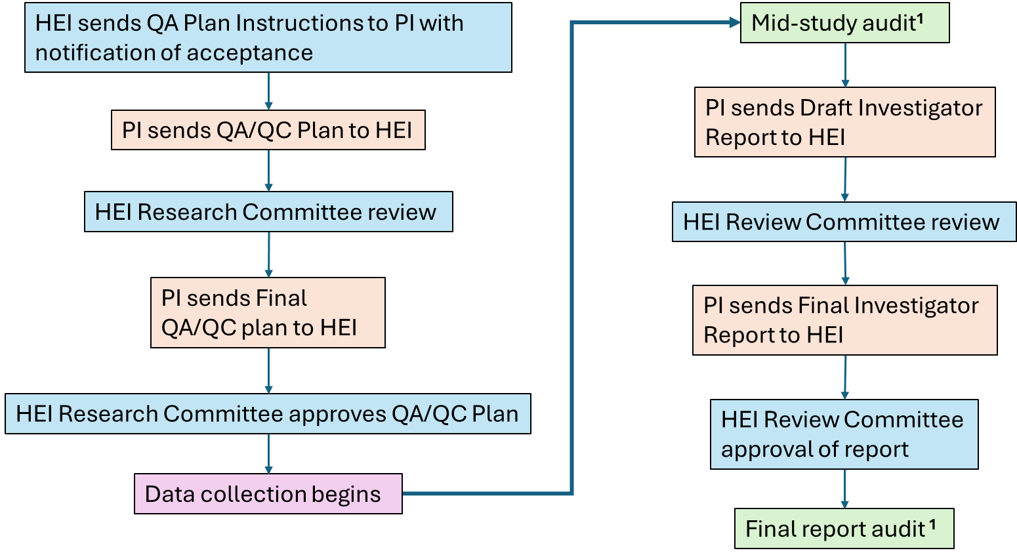
Figure 1. QA/QC Plan Revision and Audit Timeline
Key. Blue: HEI responsibilities; Orange: PI responsibilities; Green: Third-party QA/QC audits; Purple: major study dates.
¹Third-party auditors are used to conduct QA/QC audits for studies that involve human subjects or other studies that have a high potential for use in regulatory decisions; QA/QC audits might not be conducted during the course of some studies, for example, when the study is using data from administrative databases or other sources that have been extensively audited or might not be accessible or if the study’s primary focus is on methods development. In those cases, only the final report is audited by the third-party auditors.

Information about Study QA Manager
All PIs funded by HEI must assign a QA Manager who is not directly involved in the study and has the expertise to review and sign off on the QA/QC plan. Functioning independently of the HEI-funded research team, the study QA Manager ensures and documents that the team performs research in accordance with their QA/QC plan. They are responsible for review of SOPs, data, code, and documentation on the secure server. When it is time for the audit, they should have familiarity with the QA/QC plan and be available for questions. QA Managers can be included in the study budget.

QUALITY ASSURANCE AND QUALITY CONTROL PLAN

[Research Project Title]

Research Agreement #[HEI Staff insert here]

Prepared Date:

Principal Investigator: [Principal Investigator Name, Affiliation, Address]
Prepared By: [Name of research team member, whether PI or someone else]
QA Manager: [Name, Affiliation]

Quality Assurance Plan Approval and Distribution

Signatures indicate that this QA/QC plan has been approved by the Principal Investigator and the laboratory’s QA/QC Manager, that any updated plan has been approved and dated, and that the plan will be fully implemented in conducting the research project described in this document.

SIGNATURES

Principal Investigator: [Name and affiliation] | Signature:
Quality Assurance Manager: [Name and affiliation] | Signature:

VERSION HISTORY

Version Number | Date Effective | Description | Key Changes Made
 |  | Preliminary version sent to HEI staff for internal review | Not applicable
 |  | Version for review by oversight committee or panel

TABLE OF CONTENTS

I. Brief Description of Study Aims and Design and Data Flow 6
II. List of Standard Operating Procedures (SOPs) and Data Protocols 8
III. Quality Control Procedures for Data Collection 9
IV. Data Processing Procedures, Data Linkages, and Data Analyses 10
V. Data and Records Management 10
VI. List of Qualified Personnel 10
VII. Appendices 11

Brief Description of Study Aims and Design and Data Flow
This section should include a brief description of study aims and design; it summarizes the work to be detailed in the remaining sections. The data collection and processing steps should be expanded in Sections II through V below.

This section, Section I, should contain one or more flow charts that shows the data flow from raw data (i.e., “as collected”) to the final results of statistical analyses (i.e., “as used in the final statistical analyses”) both for studies that collect original data or use secondary data, such as in model-based studies. Please adapt one of the example data flow charts below (Figures 1-3) or use your own format; name the person(s) or institution responsible for each step in the process.

Text in this section can refer to the study protocol, provided as an appendix for details. HEI expects all studies to be conducted according to a written study protocol. A study protocol defines the study objectives, study design, and methods to be used. The original project plan submitted with the HEI application, along with any amendments made to the original project plan, can serve as the study protocol.

The protocol can be amended as necessary to accommodate changes in study design or approach. The amended version must be a stand-alone document and not refer to the previous version of the protocol. Any substantive changes will need to be approved by the oversight committee or panel. Older versions of the protocol should be retained for traceability.

Information to Include for Different Study Types
This section provides examples of the type of information to include for different study types in text or table. Note that this section is not all-inclusive and might not apply to every study. Please include sufficient information to allow a reviewer to replicate your study.

Environmental and Health Data:
- Anticipated number of sample locations and number of samples per location
- Sampling frequency, duration, and averaging time (for continuous monitoring)
- Number of QC samples (e.g., field replicates and blanks)
- Reporting limits (i.e., smallest concentrations of a substance that laboratory can reliably report)
- Laboratory or field analysis methods
- Instrumentation and any laboratory analyses
- Calibration methods
- Detection limits
- Health outcome definition
- Staff training
- Participant recruitment
- For remote sensing data: the spatial resolution, area to be imaged, and the degree of overpass.

Toxicology Studies:
- Animal model (species, sex, number) or in vitro system
- Exposure concentrations and route of administration
- Endpoints measured and frequency
- Sampling methods and analysis
- Instrumentation

Secondary Data:
- How appropriate data sources and variables will be identified and used in this project
- Data sources
- How the data will be obtained (e.g., via code or manual download)
- Which parameters from the secondary data will be used
- Any prior QA/QC that was done on the data, including citations as relevant
- Data exclusion criteria for this study
- Any additional quality checks that will be conducted before using the data in this study

Modeling: identify the model or modeling routines that will be developed, calibrated, and tested.

Figure 1. Sample ascertainment of original and environmental and health outcome data flow chart.
Please adapt the chart or use your own template. Name the person(s) or institution responsible for each step in the process.

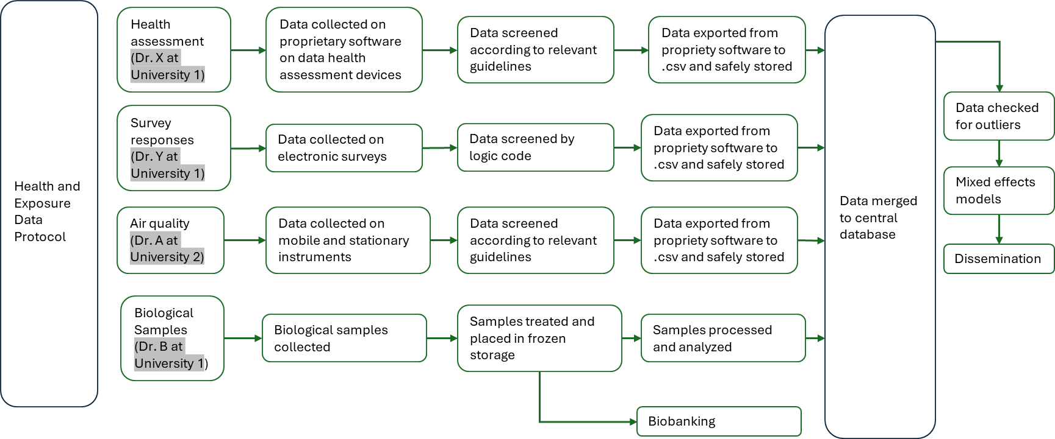
Figure 2. Sample data flow chart for studies using existing data or a combination of existing and original data.
Please adapt the chart or use your own template. List person(s) responsible for compiling the data, processing the data, and developing the model. Adapted from Griffiths et al. QA/QC plan

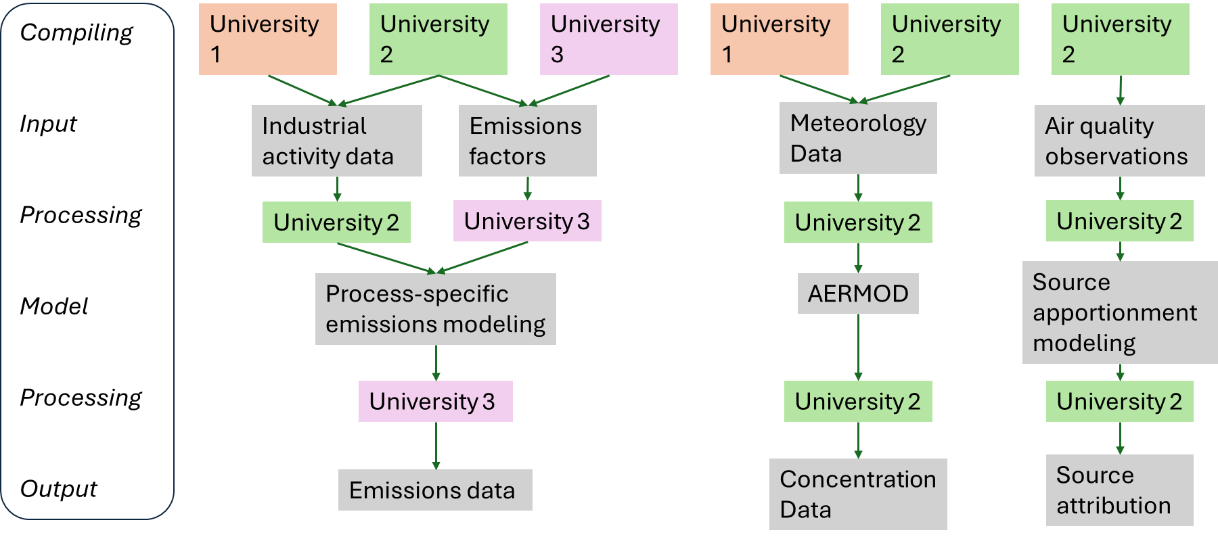
Figure 3. Sample data flow chart for modeling analysis.
Please adapt the chart or use your own template. List person(s) responsible for compiling the data, processing the data, and developing the model. Adapted from Collett et al. QA/QC plan.

List of Standard Operating Procedures (SOPs) and Data Protocols
SOPs and data protocols need to be in place for all procedures, including use of equipment and laboratory analyses—whether they generate new data or make use of previously collected data. SOPs will be used to document routine and repetitive procedures in the laboratory or field for which variability must be minimized. Investigators should use standard methods and procedures when they exist and are applicable. In case SOPs do not exist, they should be developed by individuals with the appropriate, demonstrated expertise. SOPs will describe what, when, where, how, and why in a stepwise manner. They will be sufficiently complete and detailed to ensure that the data collected are of appropriate quality.

Data protocols also include standardized procedures for processing and cleaning of the raw data and other routine or repetitive steps to work with the data. Data protocols should also be developed when making use of previously collected data or leveraging other ongoing studies. For previously collected data, the SOPs developed when those data were originally collected can be used here.

SOPs and data protocols will be uniquely identified and dated and updated as needed. Copies of all current SOPs and data protocols should be readily available for reference by the study team and by a third party. All SOPs and data protocols that have been superseded will be archived in the HEI study files.

If detailed procedures or protocols are included as attachments, include a list or table with the name (including version number and date) and purpose of each SOP or data protocol to help the reader navigate the SOPs.

Guidance on preparing SOPs is provided by the US EPA: https://www.epa.gov/sites/default/files/2015-06/documents/g6-final.pdf.

Quality Control Procedures for Data Collection
Data collection includes field or laboratory measurements, chemical analysis, health-data collection, surveys, and previously collected data, data leveraged from other ongoing studies, or secondary data.

For each type of data, the QA/QC plan should indicate QA/QC measures to be taken, such as data quality indicators (e.g., acceptance criteria, precision, bias, completeness, and representativeness established as part of the study design), sample handling and custody, frequency of checking instrument operations, and corrective actions. The QA/QC plan should refer to the SOPs and data protocols for details. For secondary data, describe quality control procedures previously conducted or procedures for determining the quality of the secondary data. Pre-existing QA/QC plans related to these data can be included in an appendix. Please adapt Table 1, below, or use your own template.

Table 1. Summary of QA QC procedures for environmental data
Operation check or measurement parameter | Acceptance criteria | Corrective action | Frequency
Initial calibration, flow and leak check, temperature check, measurement detection limit, calibration verification | Refer to SOP | Flag data, recalibrate, investigate cause, perform appropriate corrective action | How often you plan to conduct the check (e.g., daily, bi-weekly, annually)

Data Processing Procedures, Data Linkages, and Data Analyses
Data processing includes all manipulations performed on raw data (i.e., “as collected”); the QA/QC plan should describe how the data are treated, cleaned, transformed, linked, and statistically analyzed (as shown in the flow chart in Section I). For each step, the QA/QC plan should indicate QC/QC measures to be taken, use of acceptance criteria in data processing information on duplicates and blanks, and sample log sheets, and exposure assignment verification. For critical routine procedures, the QA/QC plan should refer to the SOPs and data protocols for details

Data analysis plans should be specified before research begins and summarized in the QA/QC plan, include model details and sensitivity analyses, statistical bias correction, and refer to the study protocol for details. Modifications to the data analysis plans, specific statistical procedures, and statistical code should be added to the QA/QC plan and protocol as the study progresses.

In addition, a code book or data dictionary for all the variables in the statistical models should be developed. Model-based studies should include QA/QC steps associated with model development, calibration, and evaluation.

Data and Records Management
The QA/QC plan should describe how the investigator will manage, store, and preserve documentation, records, data, code, and metadata from their generation through the archival process. The QA/QC plan should (1) identify the individuals responsible for those tasks; (2) discuss methods for managing data versions and tracking; (3) describe data security, data confidentiality, data access, and data transfer processes; and (4) describe hardware and software to be used. In the case of written records, procedures should include ways to ensure the integrity of the data or the documentation, such as dating and signing original entries and documenting, dating, and signing changes or edits with the reason for the change.

Data Access Policy
The provision of access to data underlying HEI-funded studies is an important element of ensuring credibility, especially when the studies are used in controversial public policy debates. The open and free exchange of data is also an essential part of the scientific process. Therefore, it is the policy of the Health Effects Institute to ensure access is provided expeditiously to data for studies that it has funded and to provide that data in a manner that facilitates review and verification of the work, while protecting confidentiality and self-determination of any participants or communities involved in the study, and respecting the intellectual interests of contributors to the original work. For the full HEI Policy on the Provision of Access to Data Underlying HEI- Funded Studies, see https://www.healtheffects.org/accountability/data-access-transparency.

List of Qualified Personnel
Qualified personnel will conduct the proposed research. Qualified personnel include the principal investigator, co-investigators, postdocs, students, and others who are working directly on the HEI-funded research. The investigator also appoints a qualified QA/QC manager who functions independently of the HEI-funded research.

The QA/QC plan should list the name, position, project role, and qualifications for key personnel, including the QA/QC manager. Biographical sketches in an appendix can be referenced for details. The QA/QC plan should list training procedures for personnel for the conduct of the study and describe plans to cover all the tasks in case personnel leave the study team.

Appendices
This section includes the study project plan (i.e., Full Application Form F-6), including any amendments made since the original project plan included in the application, such as HEI feedback letters and contract statement of work, as well as relevant SOPs. Appendices can also include SOPs, data protocols, biographical sketches of key personnel, statistical code, or other items.

